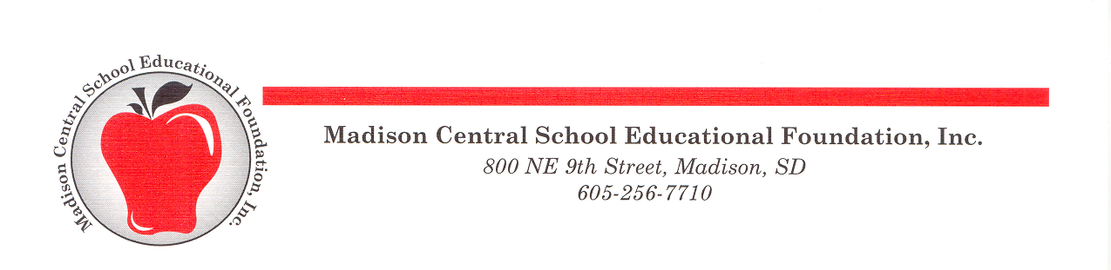

Performing & Fine Arts Grant Application

Madison Central School Educational Foundation
800 NE 9th St.
Madison, SD 57042
madisoneducationalfoundation@k12.sd.us

You must complete the grant application electronically.

Grant Applicant 1: Position School/Dept

Grant Applicant 2 (if more than 1): Position School/Dept

Grant Applicant 3 (if more than 2): Position School/Dept

Title of Project: Project will begin: and end:

Amount Requested: (max. $400) $ If amount was reduced, would you accept it? Yes No

My Principal/Director has approved this application: Yes No

Please review the Performing & Fine Arts Grant Application Criteria found in the Performing & Fine Arts Grant Guidelines to guide your application.

- Describe your project and how it enriches students’ experience in the performing and/or fine arts.

2. Describe how your project fits within and enriches your existing curriculum.

3. List all related expenses for this project and indicate the amount you are requesting through this PF&A grant. Please attach additional information, including brochures, website pages and purchasing information.

4. If this project requires additional funding from other sources, please provide that information.

