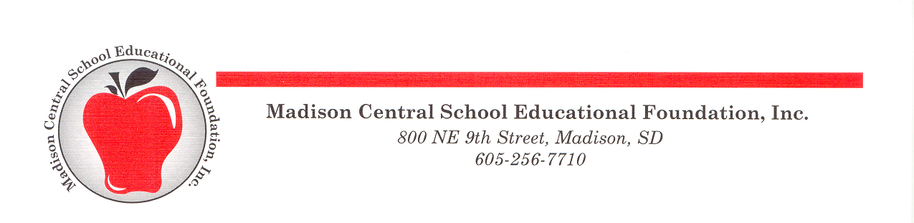

The Norm Johnson Innovative Education Grant Application

Madison Central School Educational Foundation
800 NE 9th St.
Madison, SD 57042
605-256-7710
madisoneducationalfoundation@k12.sd.us

You may complete the grant application electronically, type or print in black ink

Grant Applicant 1: Position School/Dept

Grant Applicant 2 (if more than 1): Position School/Dept

Grant Applicant 3 (if more than 2): Position School/Dept

Title of Project: Project will begin: and end:

Amount Requested: (max. $400) $ If amount was reduced, would you accept it? Yes No

Please use the rubric for the Norm Johnson Innovative Education Grant Criteria found in the Norm Johnson Innovative Education Grant Guidelines to guide your project application.

- Describe your project, how it is innovative, and how this innovation follows the curriculum.
Please indicate if there is the possibility of replication in your school or across the curriculum.

- Describe how the project will have an impact on student learning and how it will make a difference in students attaining curriculum goals. Please indicate if you are willing and ways you are willing to share the success of student learning.

- List the specific items with their costs that you are requesting for funding through the Foundation.
Please attach additional information and purchasing information.

If this project is requesting additional funding from other groups, please provide that information.

Is your principal/director aware of this grant application? Yes No
Is your technology director aware of this grant application? Yes No

