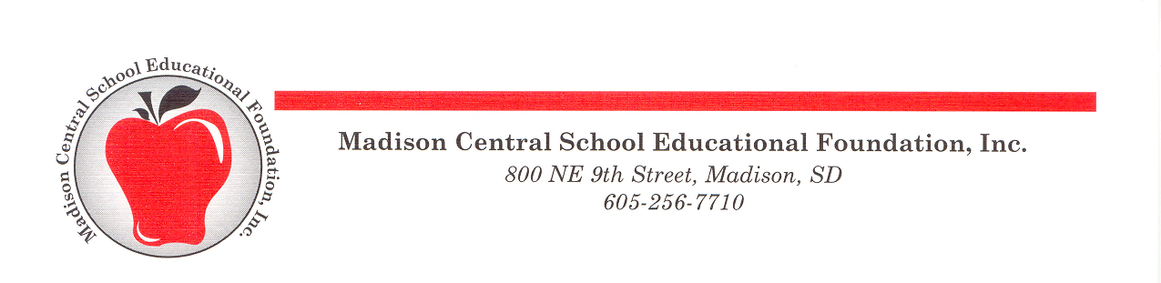

The Norm Johnson Educator Enhancement Grant Application

Madison Central School Educational Foundation
800 NE 9th St.
Madison, SD 57042
madisoneducationalfoundation@k12.sd.us

You must complete the grant application electronically.

Grant Applicant 1: Position School/Dept

Grant Applicant 2: (if more than 1): Position School/Dept

Grant Applicant 3: (if more than 2): Position School/Dept

Title of Enhancement Project or Professional Development Opportunity:

Project/Event will begin: and end:

Amount Requested: (Maximum of $400) $

My Principal/Director has given his/her approval of my grant application:

Please review the NJEE Grant Application Criteria found in the NJEE Grant Guidelines to guide your application.

- Describe your enhancement project or professional development opportunity.

- Describe how this project/opportunity will impact student learning and how it will make a difference in students meeting curriculum goals. Please indicate if you are willing and ways you are willing to share what you learn with others.

- List all related expenses for this project/opportunity and indicate the amount you are requesting through this NJEE grant. Please attach additional information, including brochures, website pages and purchasing information.

- If airfare and lodging are required for this opportunity, how will these expenses be paid for?

